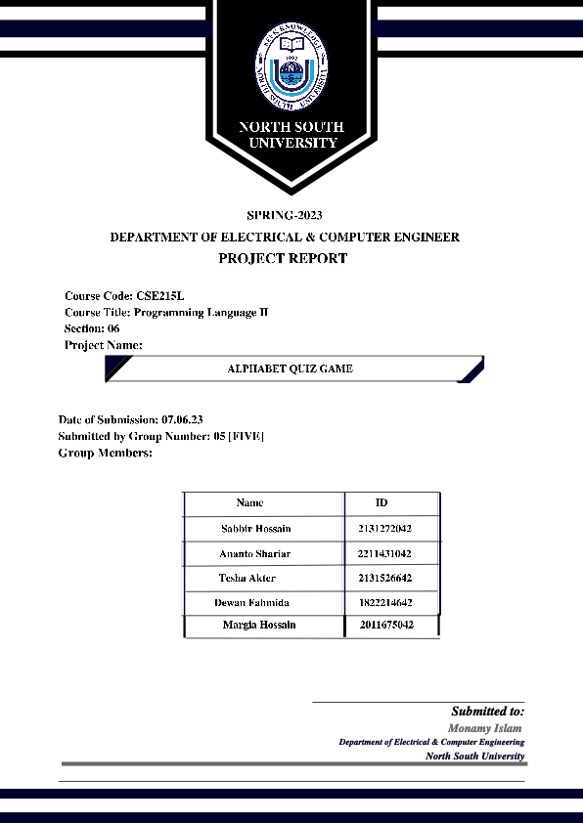

**FEATURES:**

**- Login System**

**- Instruction manual of the game**

**- Scorecard of individual players**

**- Difficulty Level**

**- Hint for each question**

**- Scoreboard of all the games played by players**

**- Reset option to delete all the data of the game**

**- Exit and Back button options .**

**EACH CLASS DETAILS:**

|  |  |
| --- | --- |
| **AlphabetGameForKids()** | **Contains the whole game , Jlabel , Jtextfield for answer , rightcounter , left counter and a remarks field(if right answer then right counter++ and remarks ‘right’ and vice versa for wrong answers.** |
| **menu()** | **Contains Jbutton for all the constructors .** |
| **register()** | **Takes user input for name , age and two Jbutton for saving the variables** |
| **User()** | **Contains two instance variables of name and age.** |
| **Questions()** | **Abstract class contains Strings of questions and answers which are instance variables** |
| **Instructions()** | **Contains Jlabels to give instructions for the game** |
| **Scoreboard()** | **Contains binary file input and output** |
| **Scorecard()** | **Gives result for each user on GUI** |

USE OF THE PROJECT :

This game we made for kids. Here, a kid can learn the alphabet and words very quickly.   
The game will open with a login page where a kid needs to write his/her name and provide us with their age. Then they will be redirected to a menu screen with options to Play, View Scoreboard, Instructions, Reset the scoreboard and exit the game. The manual for playing the game is given in the ‘Instruction’ option. When clicking on the ‘Play’ button, accessible and attractive words appear with blanks in between and all the buttons in the English alphabet. This game has three different difficulty levels. The players have to guess the correct alphabet and get points for it. Here also they have hints for each question, which will help players play their game. After clicking the button to answer the question, If the player fails to answer, negative energies will be shown on the screen. The right answer will be provided if the wrong answer is given. Correct and incorrect points will be displayed after each question is answered. The player can view his/her total score after all the questions are answered on the Scorecard. The player's data will then be stored in a file which can be viewed from the ‘View Scoreboard’ option in the menu. There is an option to reset all the data of the games played as well. The player can exit the login portal after each game is finished.

**Limitation :**

**In this game, we face several different bugs and problems, specifically on the front page when the user gives a name or age to log in, the login levels of the GUI do not work smoothly and the okay button and cancel button also in this page do not work properly. Also, in the file, when we manually check the score, this will show only the Names are showing in the file, but age and score are showing some garbage characters.**

***Future Work:***

**This is a recreational project based on educational purpose. The project will help kids understand alphabets along with words associated with it. It will help the parents ease their efforts on teaching their children. If kids are playing this game they will learn and enjoy the learning.**